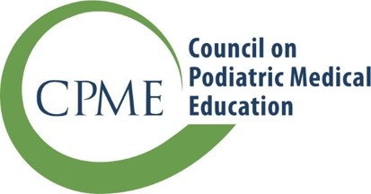
11400 Rockville Pike, Suite 220
Rockville, Maryland 20852
cpmestaff@cpme.org

www.cpme.org

  - NOTIFICATION OF A VOLUNTARY, PERMANENT
  - REDUCTION IN RESIDENCY POSITIONS

A permanent decrease in residency positions must reported to the Council on Podiatric Medical Education as a substantive change. A decrease in residency positions is a permanent, voluntary action by the sponsoring institution(s) and must be approved by both the program director and administrator(s).

If the residency program wishes to increase positions in a single year of training or increase the number of approved residents overall, an application to increase residency positions must be submitted for consideration by the Residency Review Committee (RRC), approved by the Council, and applicable fees must be paid.

Please complete all sections:

- Sponsoring Institution Information
Sponsoring institution
Address 1
Address 2
City/State/Zip

- Co-sponsoring Institution Information (if applicable)
Co-sponsoring institution
Address 1
Address 2
City/State/Zip

- Current Program Information (as defined in CPME 320, Standards and Requirements for Approval of Podiatric Medicine and Surgery Residencies (July 2023)
Category | Program  Length  (Months) |  | Number of Current Approved Positions | Number of Residents Currently in Program | New Decreased Number of Approved Positions | Effective Date
PMSR | 36 | 48 | /// | /// | ///
PMSR/RRA | 36 | 48 | /// | /// | ///

CPME requires that any medical documentation submitted must have patient identifiers redacted. Any material submitted to CPME that does not comply with these requirements will not be accepted by the RRC and Council and will be deleted.

By signing this form, the chief administrative officer(s) and the program director confirm the commitment of the institution(s) in providing podiatric residency training.

Chief administrative officer (or DIO) Date

Chief administrative officer of co–sponsoring institution (if applicable) Date

Program director Date

