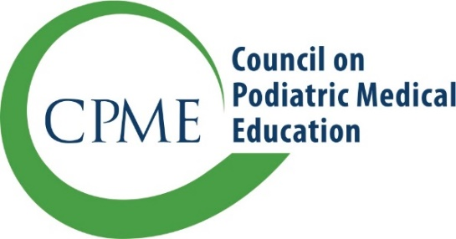
11400 Rockville Pike, Suite 220
Rockville, Maryland 20852
CPMEstaff@cpme.org
www.cpme.org

Program Transfer/Merger
Change in Sponsorship

Institutional sponsorship of a training program may be transferred from one institution to another
under certain circumstances. Please submit this form by email to your program liaison or to CPMEStaff@cpme.org within 30 days of sponsorship changes:

- Current Sponsoring Institution Information
Sponsoring Institution
Address 1
Address 2
City/State/Zip
Program Director
Program Administrator
Residency Type  Number of approved positions per training year | ☐ PMSR //  ☐ PMSR/RRA //
Number of current residents in the program | ☐ PMSR //  ☐ PMSR/RRA //

- New Sponsoring Institution Information
Sponsoring institution
Effective date of program transfer
Address
City/State/Zip
Program Director
Program Director email address, phone number
Program Administrator
Program Administrator email address, phone number

- New Sponsoring Institution Information for program mergers

Please only answer if the new sponsoring Institution currently sponsors an existing Podiatric Medicine and Surgery Residency (PMSR) or Podiatric Medicine and Surgery Residency with Reconstructive Rearfoot/Ankle Surgery (PMSR/RRA)

Type of program currently sponsored by the new sponsoring Institution and number of approved positions | ☐ PMSR //  ☐ PMSR/RRA //
Type of program and number of approved positions for the combined residency programs under the sponsorship of the new sponsoring Institution | ☐ PMSR //  ☐ PMSR/RRA //
Names and PGY year of all residents that will be transferring from the existing residency program into the combined program under the sponsorship of the new sponsoring Institution

- Documentation to be Submitted
Item | Description | Included
1. | Letter from the chief administrative officer of the original sponsoring institution acknowledging the transfer or addition of a co-sponsoring institution
2. | Letter of intent from the chief administrative officer of the new sponsoring institution
3. | List of any new administrative staff (CAO/DIO) and podiatric and non-podiatric medical faculty (with board qualification/certification status and professional qualifications)
4. | Copies of fully executed affiliation agreements between the new sponsoring institution and all affiliated training sites (if applicable)
5. | Copies of blank resident contracts if the submission occurs prior to the program transfer. Copies of signed resident contracts if the submission occurs after the program transfer.
6. | Curriculum vitae of the program director (if the director is new)
7. | Residency manual that includes all required components (refer to CPME 320, requirement 3.9)  - The mechanism of appeal  - Performance improvement methods established to address instances of unsatisfactory resident performance  - Resident clinical and educational work hours  - The rules and regulations for the conduct of the resident  - Information related to transition of Care  - Curriculum, including competencies and assessment documents specific to each rotation (refer to requirements 6.1 and 6.4)  - Training schedule (refer to requirement 6.3)  - Schedule of didactic activities and critical analysis of scientific literature (refer to requirements 6.7 and 6.8)  - Policies and programs that encourage optimal resident well-being (refer to requirement 3.13)  - CPME 320 and CPME 330 or links to these documents on the Council’s website

The Residency Review Committee will review the application for program transfer, along with resident logs, and may determine that a full or focused on-site evaluation is required.

By signing this form, the chief administrative officer(s) and the program director confirm the commitment of the institution(s) in providing podiatric residency training.

Chief administrative officer (or DIO) Date

Chief administrative officer of co–sponsoring institution (if applicable) Date

Program director Date

