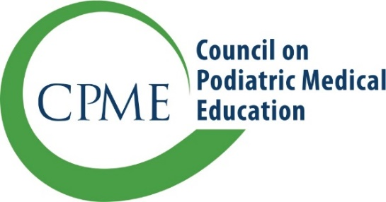
11400 Rockville Pike, Suite 220
Rockville, Maryland 20852
CPMEstaff@cpme.org
www.cpme.org

Notification of Change:
Program Director, Administrator/DIO,
or Hospital Name

CPME requires that programs inform the Council within 30 calendar days of the following:

- Resignation or termination of the program director, and/or appointment of a
new program director
- Change in the chief administrative officer, DIO, or designee
- Change in the name of the sponsoring institution

Please submit this form by email to your program liaison or to CPMEStaff@cpme.org as formal notification of changes.

Sponsoring Institution Information - Current name
Name of sponsoring institution
Address 1
Address 2
City/State/Zip
Requested Change | Change in hospital name  Change in program director  Change in chief administrative officer/DIO
Date submitted

Current Program Information (as defined in CPME 320, Standards and Requirements for Approval of Podiatric Medicine and Surgery Residencies (July 2023)
Category | Program Length (months) | Number of approved positions | Current number of residents
PMSR | 36 | // | //
PMSR/RRA | 36 48 | /// | ///

Please only fill out the boxes for the requested change:

Sponsoring Institution Change in Name
Previous name of sponsoring institution
New name of sponsoring institution
Address 1
Address 2
City/State/Zip
Program director name
Reason for change
Please list any email changes associated with hospital name change (program director, DIO, program coordinator)

Program Director Information – Change in Program Director
Previous Program Director Name
New Program Director Name
Office Address 1
Office Address 2
City/State/Zip
Telephone
Mobile Phone
Email
Board certification
Effective start date
Please attach a current CV for the new program director

Chief Administrative Officer/DIO Information – Change in CAO/DIO
Previous Name
New Name, Title
Office Address 1
Office Address 2
City/State/Zip
Telephone
Mobile Phone
Email
Effective start date

