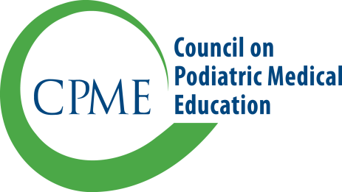9312 Old Georgetown Road

Bethesda, Maryland 20814

301-581-9200

  - APPLICATION FOR INCREASE OF FELLOWSHIP POSITIONS

Increases in fellowship positions are considered and authorized by the Residency Review Committee. The application must be submitted prior to activation of the fellowship position(s), preferably at least six months before the anticipated starting date. The effective date of granting an authorization of increased fellowship positions by the Residency Review Committee will be no earlier than the date on which the program has both authorization of the increase and the additional fellow(s) in place. A program on probationary approval may not request an increase in positions.

Please submit this form via the CPME portal and any of the documentation in response to items 3-6 along with permission for members of the committee to review the logs online. Hand-written responses and hard copy documentation will not be accepted.

An application fee, made payable to the Council on Podiatric Medical Education, must accompany the application. The application will not be processed until the sponsoring institution submits all required materials, including the application fee. Fellowship Fees are posted on the CPME website.

- Institution Information
Sponsoring institution
Address 1
Address 2
City/State/Zip

- Fellowship Information
Type of Fellowship(s)
Current Length of Training and Number of Positions | 12 Months | 24 Months | /
Proposed Length of Training and Number of Positions | 12 Months | 24 Months
Anticipated Effective Date for the Increase

- Podiatric and Non–Podiatric Staff.
The request is based on an increase in active podiatric staff and/or non-podiatric medical staff.  If yes, please complete the chart below. |  |  |  |  | Yes | No
Name and Degree  (DPM, MD, DO) |  | Certification  (e.g. ABPM, ABFAS) | Type of training  (i.e. podiatric surgery, podiatric medicine, other) | Category and Volume of Cases  (recent 12 moths) | Anticipated increase in Volume  (% of cases)
Comments:

- New Training Site(s): If training is offered for the first time in another institution(s), provide the following information for each training site (e.g., hospital, surgery center, private practice office). For each institution identified below, provide copies of accreditation documents (e.g. Joint Commission and AAAHC) and copies of executed affiliation agreements between the sponsoring institution and the affiliates.
Name |  | City, State | Accredited  By | %  of Training  (Approx.) | Number of Patient Visits (most recent 12 months) | Coordinator
 |  |  |  |  |  | Staff? | Name
Comments:

- List any increase or decrease in training experiences through the sponsoring institution or other affiliated facilities. If the program has either developed new training experiences or revised existing training experiences, provide an updated copy of the fellowship’s curriculum, competencies, and assessment documents.

- Use the following space to clarify additional training experiences that are available to justify the increase in positions. The sponsoring institution is invited to append to this application any additional statement or information that may provide further evidence of the institution’s ability to train the proposed number of fellows.

The Residency Review Committee reserves the right to request further information for use in determining authorization of increased fellowship positions.

Program Director Date

Chief Administrative Officer Date

